Caitlyn Jones
Prof. Yangyang Wang
MATH 40A: Intro to Applied Math
2 October 2024
Lab 2
- To plot the results of the frequency distribution of the Gettysburg address, I first called the function wordcount(filename) on the text file gettysburg.txt.
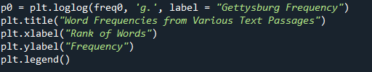
Then, I plotted the frequency results on a graph with labels, axes, and a legend.

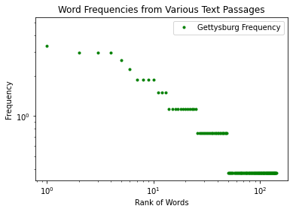

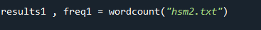
- For my random text file, I chose an excerpt from my favorite movie High School Musical 2. I followed the same steps as before to compute frequency and then graphed it on the same graph as before.

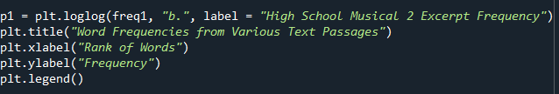

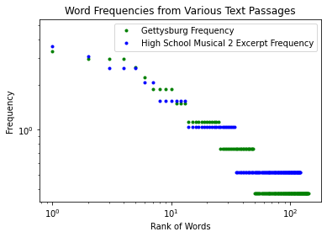

The top words in both passages are similar, as they are all articles or very common words in the English language. The differences arise when the words become more specific to the passage.
- My data does not agree with Zipf’s law, as the most frequent words appear roughly the same amount of time, give or take a few instances.
- To compute the entropy based on the equation $H= -\sum_{i=1}^{M}{f_{i}\log_{2}\left(f_{i}\right)}$, I created a function entropy(frequency) that takes in the frequency from the output of wordcount(filename) and first assigns that value to f. Then, I made a variable coeff that computes the coefficient in the summation formula. Finally, I created a variable summation that will hold the computed sum of the equation.
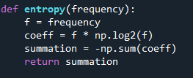

- To measure the entropy of each text, I called the function entropy(frequency) on freq0 and freq1, which were the results from calling wordcount(filename) on both texts.

The Gettysburg Address has a higher information content because it has a higher entropy.

